Mathematics for the master degree students, ICEF
Final exam (January 12, 2009)

Final exam consists of the two parts: A and B. Part A lasts for 110 minutes.
Upon completion of that part the papers will be collected and the students will have 10 minutes break.
Part B lasts for 70 minutes.
Students should answer eight of the following nine questions: six from Part A and two from Part B.
Points will be deducted for the insufficient explanation within your answers.

Part A.
Answer all SIX questions of this section. Each question is worth 10 points.

1. In the first bag there balls numbered from 0 to 9, in the second bag there are balls numbered from 1 to 10. Two balls were selected. You know that one ball was selected from the first bag and one from the second one. You will select at random one ball from these two and you will know only its number. Let’s denote its number by X and the number of the other of the two balls by Y.
Find E(Y|X), optimal strategy for risk-neutral player.
2. The random variable  is uniformly distributed on [0;a]. The random variable is uniformly distributed on [0;].
Find 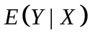, 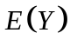 and 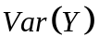.
3. Let 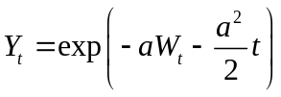.
a) Using Ito’s lemma find 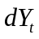.
b) Using your result in point a) find 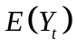 and 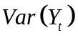.
4. Find extremals for the integral 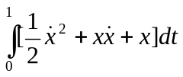when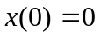 and 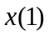 is chosen freely.
5. Solve the bounded control problem: 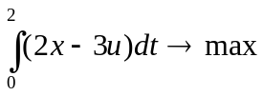, subject to 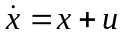, 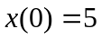, 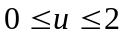, where 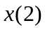is free.
6. Consider the following optimization problem: maximize 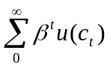, subject to 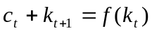, 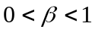, where both the utility function 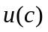 and the production function 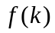 have the standard properties of monotonicity and strict concavity. Let the state variable be and denote the next period value of as 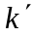. Substitute 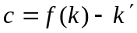 into utility function and write down the Bellman equation.
Using the formal differentiation of the Bellman equation with respect to under the sign of , and drawing FOC from Bellman equation, exclude the value function and find the equation which combines the values of 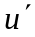 and 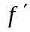 at the adjacent time periods.

Part B.
Answer two questions out of the three from this section. Each question is worth 20 points.
Part B lasts for 70 minutes.
1. In the framework of the Black and Scholes model find the price at  of an asset that pays 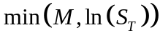 at time , where 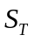 - denotes the price of one share at time , M – arbitrary constant, specified at the moment of the issue.

2. The price of a share in euros is driven by the equation 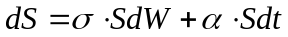, the dollar/euro exchange rate is driven by the equation 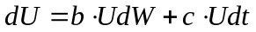.
Find the current price in dollars of a European call option with maturity date T, strike price K.

3. Consider the profit-maximizing problem for a representative competitive firm 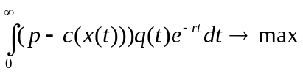, subject to (*) 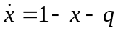, where the state variable 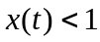 represents a nonrenewable stock resource (oil) that depletes according to the equation (*) and 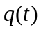 is the extraction rate. Here 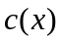 is a cost function of the extraction that is defined by 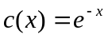. The price of oil is assumed to be constant and equal where 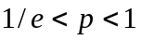. The optimization problem is to choose to maximize the discounted profits 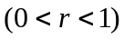.
- Derive necessary conditions.
- Prove that the steady-state exists and is unique.

